

Mini Project Report - 08

Master of Computer Application
Semester – I

Sub: Front-End Frameworks and Technologies

Topic: JavaScript Grade Calculator

By
Name: YUVRAJ PAARTH
Reg no: PROV/ASAC/MCA/7/26/083

Faculty Name: VEERA RAGHAV K

Faculty Signature: _______________

Department of Computer Application
Alliance University
Chandapura - Anekal Main Road, Anekal
Bengaluru - 562 106
August 2026

INDEX

sl no | Topics | Pg no
1 | Introduction | 2
2 | Input | 3-8
3 | Output | 9-11
4 | Conclusion | 12

INTRODUCTION
An interactive Grade Calculator web application designed to help students calculate their overall academic performance. Built with semantic HTML, custom CSS styling, and vanilla JavaScript, the calculator provides a user-friendly interface for entering student information and subject marks, automatically computing total scores, averages, percentages, and letter grades.
The project is developed using fundamental web technologies: HTML5 for semantic structure, CSS3 for responsive styling and layout, and JavaScript for dynamic calculations and form validation. The application utilizes CSS flexbox for button layouts and simple DOM manipulation methods for real-time result updates.

INPUT

<!DOCTYPE html>
<html lang="en">
<head>
<meta charset="UTF-8">
<meta name="viewport" content="width=device-width, initial-scale=1.0">
<title>Grade Calculator</title>
<style>
* {
margin: 0;
padding: 0;
}
body {
font-family: Arial, sans-serif;
background-color:#9be6ffa5;
padding: 20px;
}
h1 {
text-align: center;
margin-bottom: 20px;
font-size: 24px;
}
.section {
margin-bottom: 20px;
padding: 15px;
border: 1px solid #999;
background-color: #f5f5f5;
}
.section h2 {
font-size: 16px;
margin-bottom: 12px;
color: #333;
}
label {
display: block;
margin-bottom: 5px;
font-size: 14px;
}
input {
width: 100%;
padding: 8px;
margin-bottom: 10px;
border: 1px solid #666;
font-size: 14px;
}
.button-group {
display: flex;
gap: 10px;
margin-top: 20px;
}
button {
flex: 1;
padding: 10px;
border: 1px solid #333;
font-size: 14px;
cursor: pointer;
background-color: #ddd;
}
button:hover {
background-color: #ccc;
}
.result-section {
margin-top: 20px;
padding: 15px;
border: 1px solid #999;
background-color: #f5f5f5;
display: none;
}
.result-section.show {
display: block;
}
.result-item {
margin-bottom: 10px;
font-size: 14px;
padding: 8px;
border-bottom: 1px solid #ddd;
}
.result-item:last-child {
border-bottom: none;
}
.result-label {
font-weight: bold;
}
.result-value {
float: right;
}
.status {
padding: 10px;
margin-top: 10px;
text-align: center;
border: 1px solid #333;
font-weight: bold;
}
.status.pass {
background-color: #90EE90;
}
.status.fail {
background-color: #FFB6C6;
}
</style>
</head>
<body>
<div>
<h1>Grade Calculator</h1>
<!-- STUDENT INFORMATION SECTION -->
<div class="section">
<h2>Student Information</h2>
<label>Full Name:</label>
<input type="text" id="name" placeholder="Enter student name">
<label>Roll Number:</label>
<input type="text" id="rollno" placeholder="Enter roll number">
<label>Class:</label>
<input type="text" id="class" placeholder="Enter class">
</div>
<!-- SUBJECTS & MARKS SECTION -->
<div class="section">
<h2>Subject Marks (Out of 100)</h2>
<label>Mathematics:</label>
<input type="number" id="math" placeholder="Enter marks">
<label>English:</label>
<input type="number" id="english" placeholder="Enter marks">
<label>Science:</label>
<input type="number" id="science" placeholder="Enter marks">
<label>Social Studies:</label>
<input type="number" id="social" placeholder="Enter marks">
</div>
<!-- BUTTONS -->
<div class="button-group">
<button onclick="calculateGrade()">Calculate</button>
<button onclick="resetForm()">Reset</button>
</div>
<!-- RESULTS SECTION -->
<div class="result-section" id="resultSection">
<h2>Results</h2>
<div class="result-item">
<span class="result-label">Total Marks:</span>
<span class="result-value" id="totalMarks">-</span>
</div>
<div class="result-item">
<span class="result-label">Average:</span>
<span class="result-value" id="average">-</span>
</div>
<div class="result-item">
<span class="result-label">Percentage:</span>
<span class="result-value" id="percentage">-</span>
</div>
<div class="result-item">
<span class="result-label">Grade:</span>
<span class="result-value" id="grade">-</span>
</div>
<div class="status" id="statusMessage">-</div>
</div>
</div>
<script>
function calculateGrade() {
let name = document.getElementById('name').value;
let math = Number(document.getElementById('math').value);
let english = Number(document.getElementById('english').value);
let science = Number(document.getElementById('science').value);
let social = Number(document.getElementById('social').value);
let total = math + english + science + social;
let avg = total / 4;
let percent = (total / 400) * 100;
let grade;
if (percent >= 90) {
grade = "A";
} else if (percent >= 80) {
grade = "B";
} else if (percent >= 70) {
grade = "C";
} else if (percent >= 60) {
grade = "D";
} else {
grade = "F";
}
let msg;
if (percent >= 40) {
msg = "PASS";
} else {
msg = "FAIL";
}
document.getElementById('totalMarks').innerText = total;
document.getElementById('average').innerText = avg;
document.getElementById('percentage').innerText = percent + "%";
document.getElementById('grade').innerText = grade;
document.getElementById('statusMessage').innerText = name + " - " + msg;
let status = document.getElementById('statusMessage');
if (msg == "PASS") {
status.className = "status pass";
} else {
status.className = "status fail";
}
document.getElementById('resultSection').classList.add('show');
}

</script>
</body>
</html>

OUTPUT

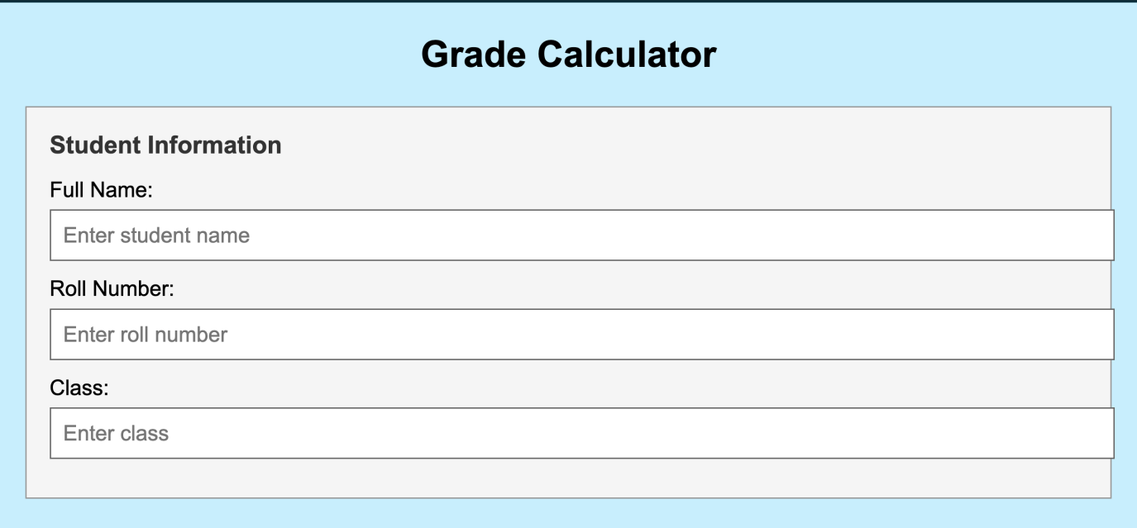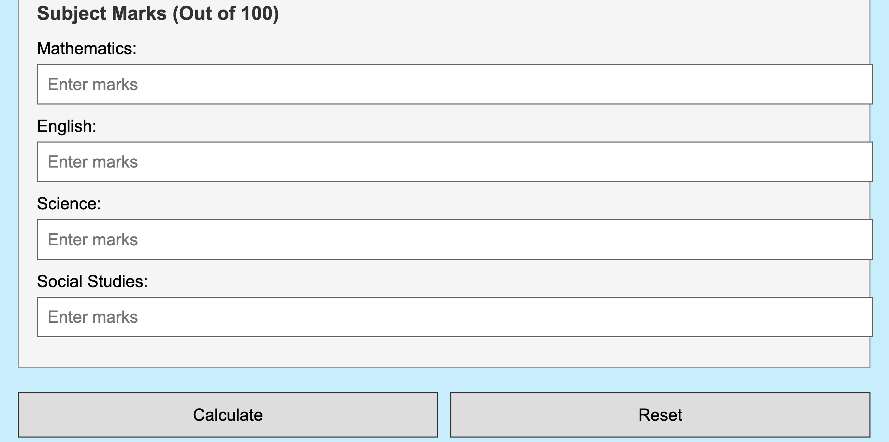

CONCLUSION

The Grade Calculator project successfully combines HTML, CSS, and JavaScript to create a simple, functional tool for calculating student grades. The application effectively captures student information, processes subject marks, and automatically computes total scores, averages, percentages, and letter grades. The color-coded results provide clear visual feedback for pass/fail status, making it user-friendly and practical. This project demonstrates core web development concepts including form handling, conditional logic, and DOM manipulation, providing a solid foundation for building interactive web applications.

